OVERALL PROGRAMME EVALUATION REPORT
SEP Scale Masterclass Module 2 Tanzania (25th May 2026 - 29th May 2026)
No. of Respondents: 217
No. of Participants: 217
Response Rate: 100%
--------------------------------------------------

Faculty Reports

Dr. Geoffrey Ikavulu Injeni - Long-term sustainability planning
Evaluation Parameter | (%) Individual Score | (%) Programme Average
Punctuality (Commencement and Completion of Sessions) | 97 | 95
How well do you understand the core concepts presented? | 86 | 90
Rate your confidence in applying the new skills learnt | 90 | 87
Degree of Faculty preparedness for the sessions | 97 | 92
Content and methodology of the program | 93 | 90
Quality of class and group discussions | 91 | 90
The information presented in the course is relevant to my work (ministry) | 94 | 90
Average scores | 93 | 91

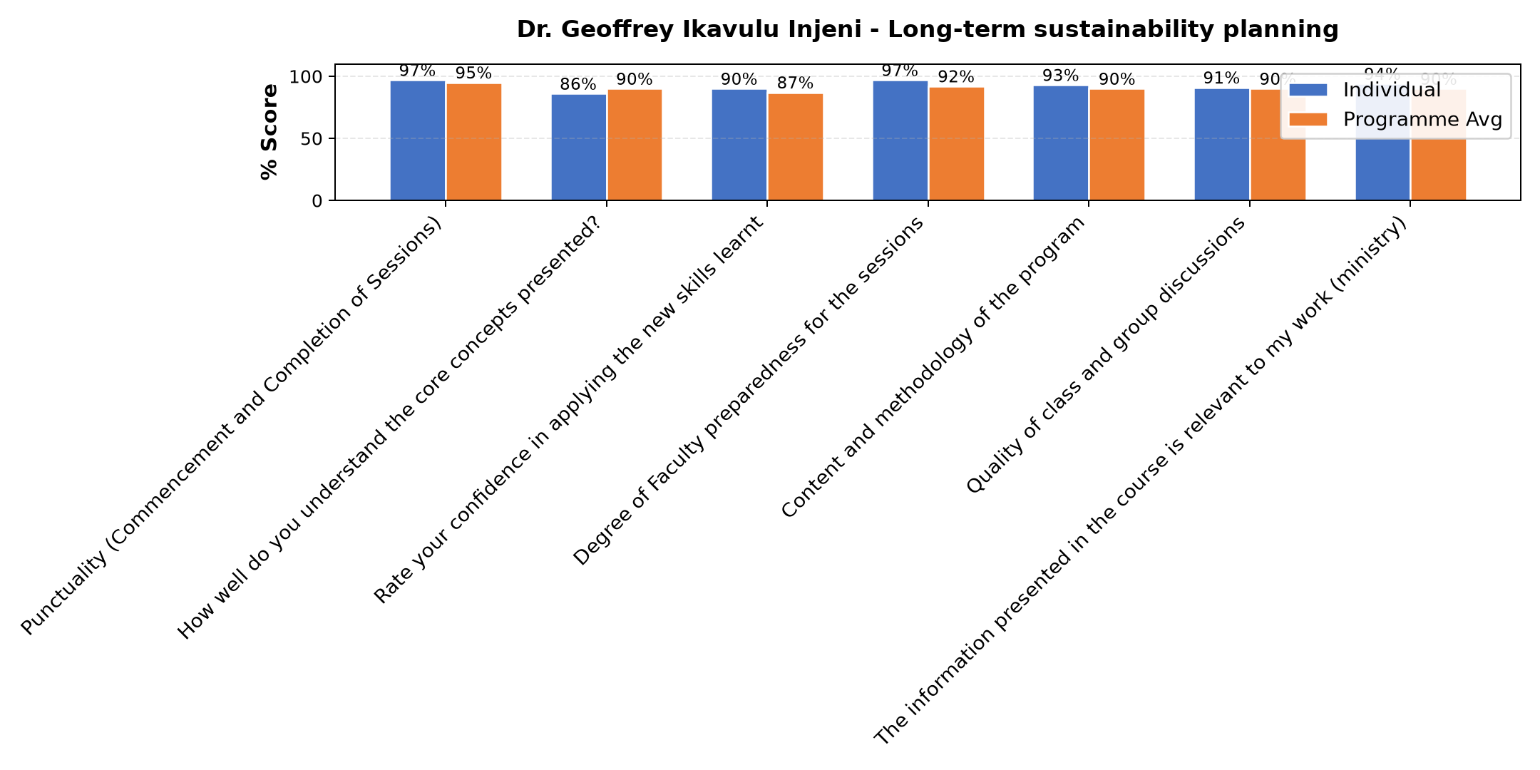

Comments & Feedback
- • Some barriers that might prevent me from applying what I learned about long-term sustainability planning include, lack of enough time for proper implementation and follow-up, insufficient support from stakeholders, and challenges in maintaining consistency in planning and monitoring activities. Changes in market conditions and limited access to reliable data may also affect effective long-term planning.
- • The possible barrier would be managing long-term assets which we buy and remain unused for long time. For instance, we bought land 3 years ago for construction but we are still unable to construct due to financial difficulties.
- • No barriers encountered so far. May be during implementation it might occur.
- • There is no berries is just considering what has been said.
- • May be lack of finance or climate change
- • Capotal
- • I will try hard to,aply the methods you taught us
- • No
- • No any barriers
- • Internet

Dr. Isaac Muiruri Gachanja - Review (identify gaps/challenges) your business plan from module 1 || Decide key issues for long-term sustainability || Identify areas where support is needed
Evaluation Parameter | (%) Individual Score | (%) Programme Average
Punctuality (Commencement and Completion of Sessions) | 92 | 95
How well do you understand the core concepts presented? | 91 | 90
Rate your confidence in applying the new skills learnt | 83 | 87
Degree of Faculty preparedness for the sessions | 92 | 92
Content and methodology of the program | 88 | 90
Quality of class and group discussions | 92 | 90
The information presented in the course is relevant to my work (ministry) | 89 | 90
Average scores | 90 | 91

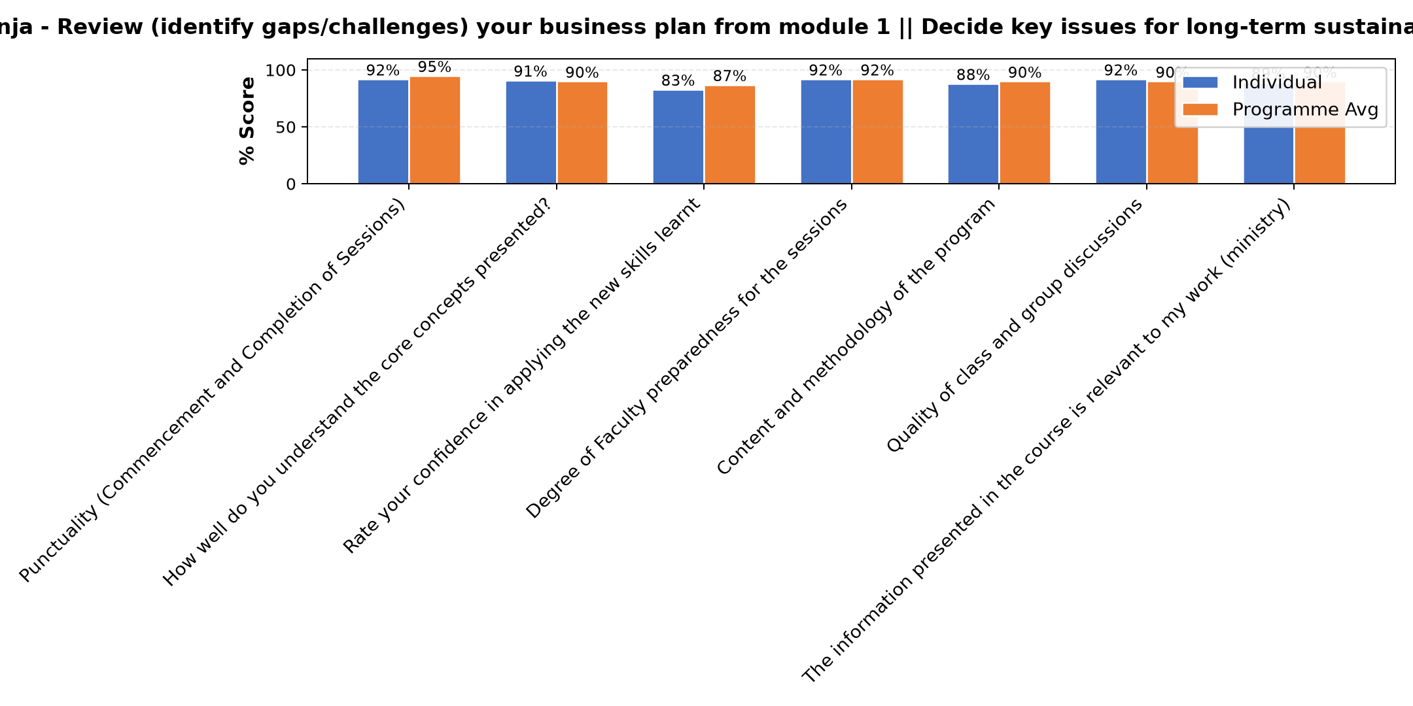

Comments & Feedback
- • Network
- • Some barriers that might prevent me from applying what I learned, lack of enough resources and financial support, and balancing work responsibilities with implementing new ideas. Another challenge may be resistance to change from people around me or difficulty in accessing continuous mentorship and support. However, with commitment, teamwork, and proper planning, I believe these challenges can be overcome.
- • Economic hardship
- • Enough capital
- • Excellent
- • No
- • Funds
- • The berriers which can prevente me from what I have learnt is just insufficient of capital to make our social interprise atractive to our customers
- • Nothing
- • I hope that there will be no barriers, may be from our fellow workers in the daily activities.If this happens we will look for good ways to perform our work.
- • If the congregation will allocate me to work in area which is irrelevant to what I have learned.
- • Invironmental competition
- • Customers delay their payments.

Tim Kipchumba - Review current funding of social enterprise || Identify Funding Gaps || Preparing funding plan
Evaluation Parameter | (%) Individual Score | (%) Programme Average
Punctuality (Commencement and Completion of Sessions) | 98 | 95
How well do you understand the core concepts presented? | 90 | 90
Rate your confidence in applying the new skills learnt | 84 | 87
Degree of Faculty preparedness for the sessions | 91 | 92
Content and methodology of the program | 89 | 90
Quality of class and group discussions | 87 | 90
The information presented in the course is relevant to my work (ministry) | 87 | 90
Average scores | 89 | 91

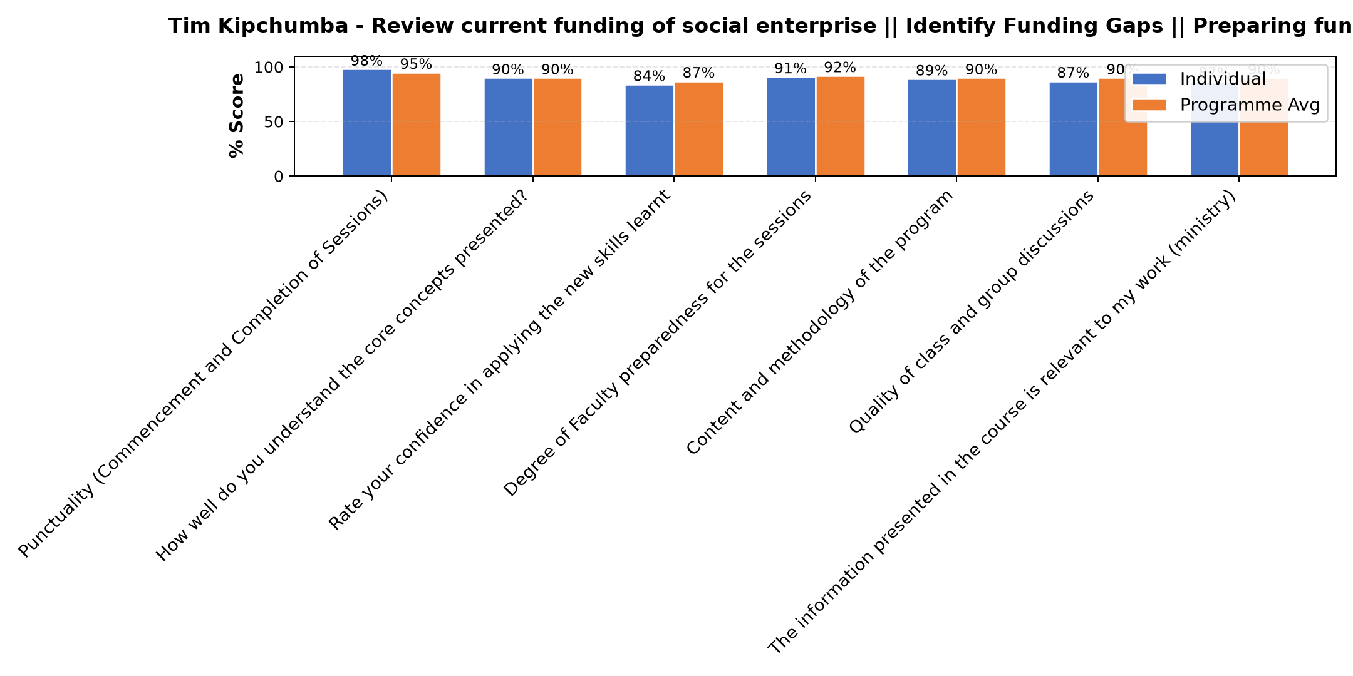

Comments & Feedback
- • Enough capital
- • Benefactors
- • The subject was good
- • A big problem is lacking money, which would help us in our plans which are not yet finished like fence administration and so on. But we are struggling to get some money.
- • What I learned was clear it is now on my side to put into implimantation
- • Resistance to change
- • Network
- • Good participation
- • Economic barriers
- • Lack of good connection with right donors to support our SE

Bernard Chege - Social impact measures and planning
Evaluation Parameter | (%) Individual Score | (%) Programme Average
Punctuality (Commencement and Completion of Sessions) | 94 | 95
How well do you understand the core concepts presented? | 91 | 90
Rate your confidence in applying the new skills learnt | 91 | 87
Degree of Faculty preparedness for the sessions | 89 | 92
Content and methodology of the program | 91 | 90
Quality of class and group discussions | 89 | 90
The information presented in the course is relevant to my work (ministry) | 91 | 90
Average scores | 91 | 91

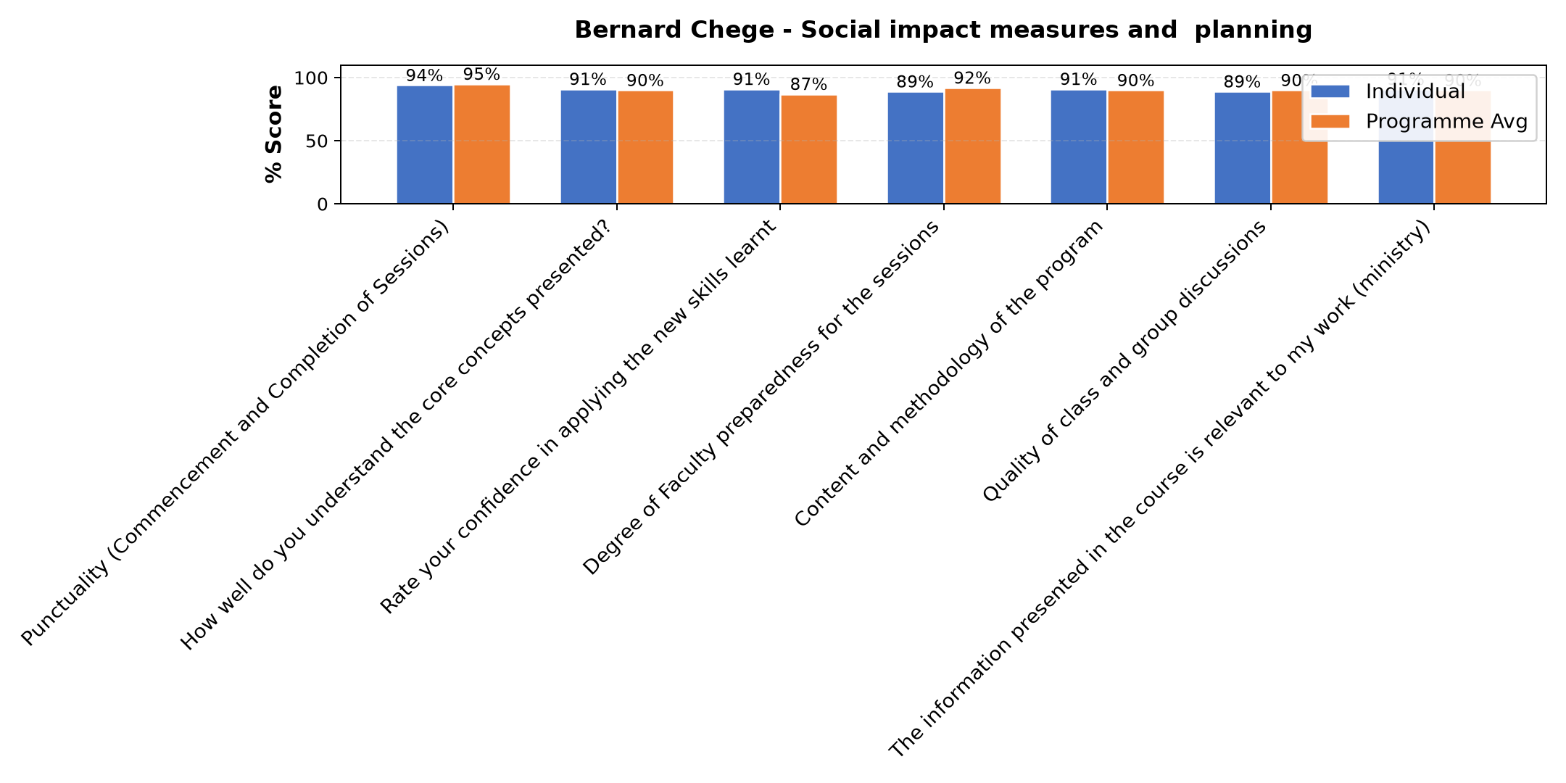

Comments & Feedback
- • Network
- • Good presentation
- • Some barriers that might prevent me from applying what I learned include limited financial resources, lack of enough time for proper planning and implementation, and difficulty in accessing accurate data for measuring social impact. In addition, limited support from stakeholders and challenges in monitoring and evaluating progress may also affect the application of the knowledge gained. However, with continuous learning, teamwork, and proper planning, these challenges can be managed effectively.
- • There is no barries in planning.
- • Internet problem
- • What have learnt have no any barrier it's my flexibility to cope well with team members to make sure that everything goes smoothly with the help of this knowledge gained
- • Capital
- • Environmental berriers
- • We need to do monitoring and evaluation to track changes. This needs human capital and funds which is scarce.
- • Network
- • Lack of propper equipments
- • Well done

Department Reports

Are there any other comments and/or suggestions that you may want to add?

Comments & Feedback
- • Thank you very much.
- • I suggest this seminar to do after three months
- • If such classes could be arranged during afternoon hours in the future. It would be better
- • Just very good man
- • The programs should continue for more enlightment
- • Sometimes out time is very limited. We failed to participate well in the whole session
- • Ever ready to help
- • No comment
- • No
- • Realy enjoyed

Further Comments

Comments & Feedback
- • The session on planning for sustainability was very insightful and practical. It helped me reflect on the long-term vision of my social enterprise and the importance of proper planning, resource management, and sustainability strategies. I appreciate the facilitators for the interactive learning experience.
- • No comment
- • No
- • Thank you so much
- • It is good and understandable
- • It is understandable and good
- • Thank you very much.
- • We thank you for this course you ara giving us because is helping us to get more new ideas inorder to grow our social interprise.
- • Good reflection
- • I thank Dr Isac and all who prepared this program for us. God bless you all.
- • The course was good well presented and need more notes and more clarifications
- • Thanks for a very good presentation and your support
- • Good
- • I'm planning to struggle for my enterprise for it to be successful
- • To offer small discounts for early payments

Further Comments

Comments & Feedback
- • Excellent
- • No comment
- • I am grateful for this training because it has increased my understanding of social impact measurement and the importance of sustainability planning. The training was very beneficial and has given me knowledge that will help improve my work and social initiatives. I would like to see more trainings like this organized regularly to continue building skills and experience.
- • I ma happy to learn this model I hope will help me in our social interprise. Thank you.
- • It's better to do onsite
- • We really appreciate the class of today. Well done. May God blessed him abundantly
- • No
- • The lesson was so good
- • It was great
- • God bless the organisers and Mr. Bernard for this valuable support we are getting to improve our SEs
- • I understood very well .thank you.
- • The Pofessor was excellent
- • Thanks alot
- • Florencia Sr.
- • It was good seminar .
- • The class was very inspiring
- • It was good seminar .

Further Comments
Evaluation Parameter | (%) Score
Punctuality (Commencement and Completion of Sessions) | 100
How well do you understand the core concepts presented? | 100
Rate your confidence in applying the new skills learnt | 100
Degree of Faculty preparedness for the sessions | 100
Content and methodology of the program | 100
Quality of class and group discussions | 100
The information presented in the course is relevant to my work (ministry) | 100
Average score | 100

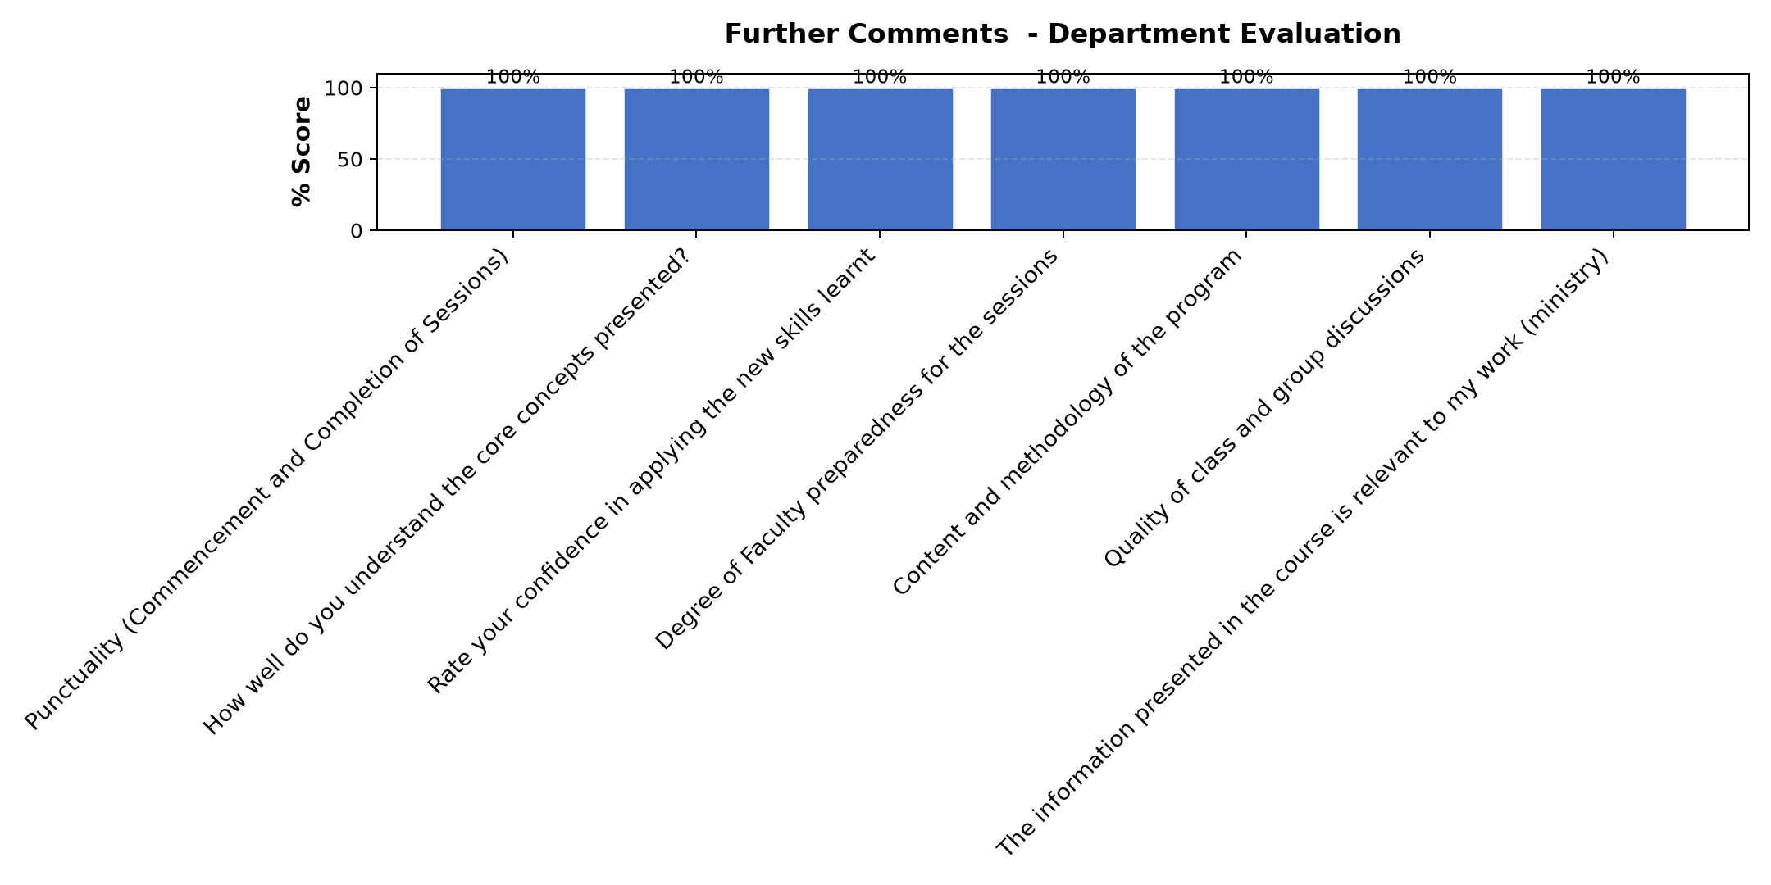

Comments & Feedback
- • Thank you Br Tim
- • Thanks for the good lesson
- • Thanks alot
- • At the begining I had a problem of not having internet I didn't gaian more.
- • You are an excellent lecsurer
- • The session was good. Thank you Br Tim
- • Good presentation
- • No comment
- • Excellent
- • A wonderfully sesions
- • Good
- • Gratitude to Mr. Kipchumba for.his valuable presentation
- • Good
- • Thank you for the valuable and informative session. The training was well organized, interactive, and relevant to our work and social enterprises. I especially appreciated the practical examples and group discussions. I look forward to more sessions in the future.
- • I truly enjoyed this class! God bless you all
- • The lessons were good but time was not enough for all groups to present. For next may be need more time. But overall all good
- • The session was well prepared and we would like to make effort to follow the advice given in this session.
- • All I can say is with grateful heart a word of thanks. May the good Lors bless all of you, reward you abandantly. All the best
- • No
- • Thank you for patience, we were slow to understand but you were patient with us
- • Well understood
- • Thanks alot
- • Thank you very much.

Overall Evaluation
Evaluation Parameter | (%) Score
Overall program evaluation | 96
Average score | 96

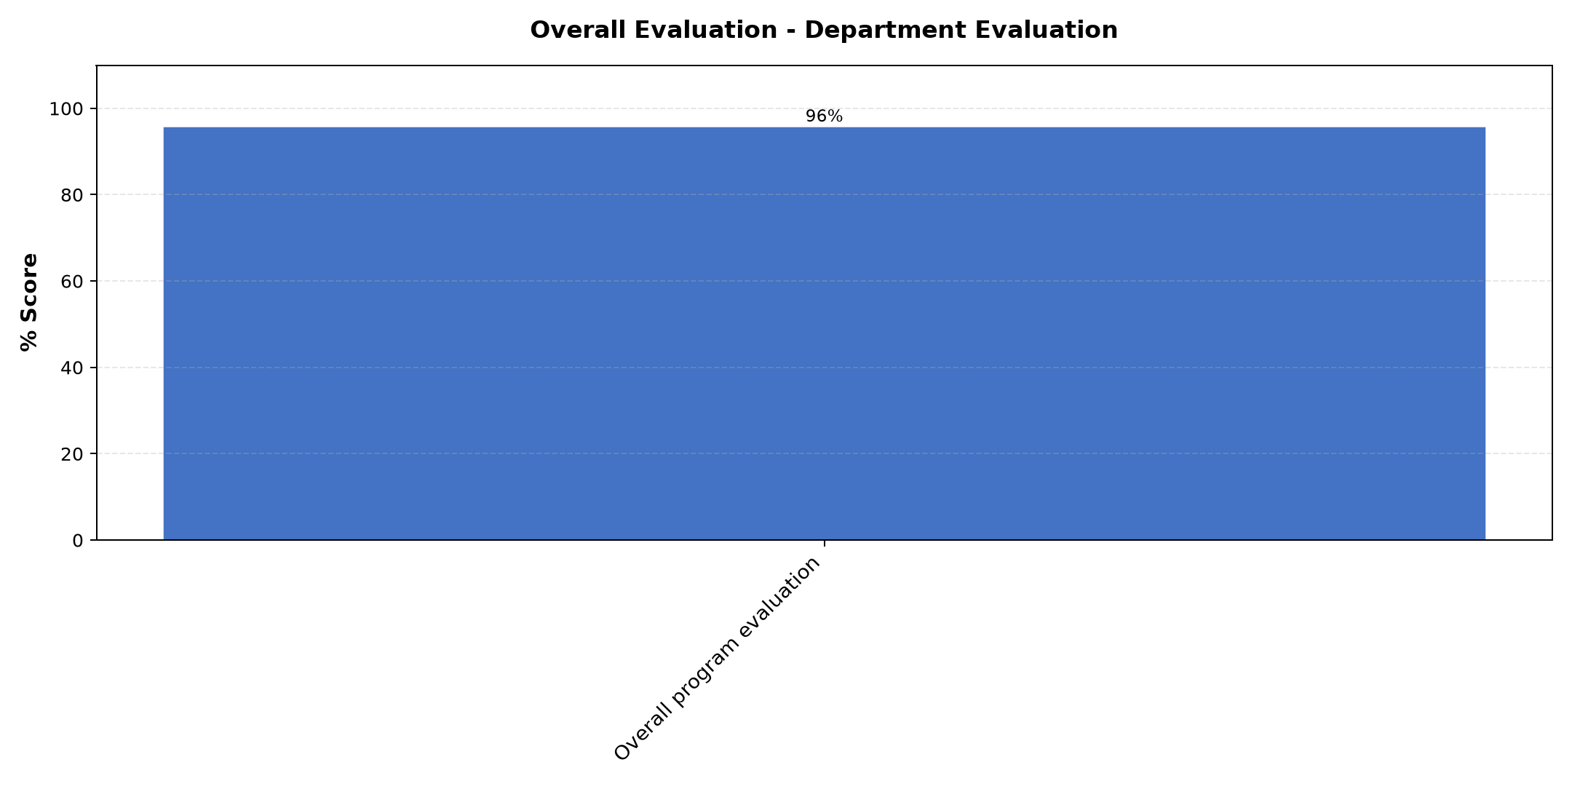

Comments & Feedback
- • All area are connected to each other.
- • On how to use vision mission and charism in our social enterprises and leadership.
- • Leadership and Social impact
- • Customer segmentation
- • Business plan
- • Impact measurement of social enterprise: on financial, customer , process, human development and social this has helped me on how yo deal with different aspects in the place of my enterprises for better growth
- • Th most important area is to make evaluation on our project per year
- • How to manage a social enterprise
- • Types of Color
- • Key performance key resources and guidance.

Program Manager (Venance Mwakangale)
Evaluation Parameter | (%) Score
Punctuality in sending materials and programme information | 100
Communication skills(verbal and written) | 99
Response to programme enquiries via email, whatsapp and calls | 97
Accessibility and willingness to support when needed | 99
Quality of service / professionalism | 98
Average score | 99

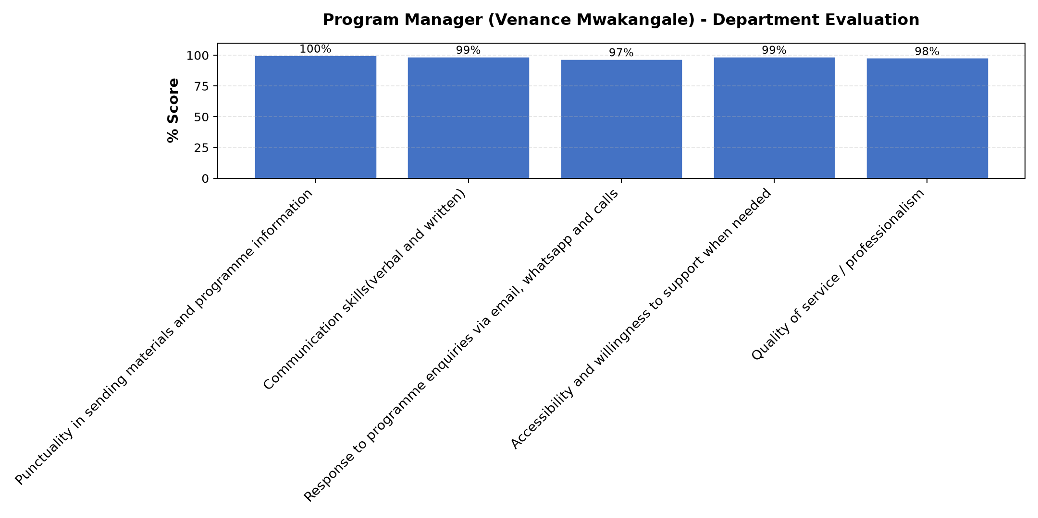

Comments & Feedback
- • Thank you very much for reminding us always.God bless you.
- • Continue to be a coordinator
- • No
- • He is a very good coordinator
- • Venance is a great coordinator. He works tirelessly with patience
- • Excellent, he deserves all. Very smart
- • All topics were very interesting in our project
- • Excellent
- • Very good
- • God bless you Venance! Keep it up!
- • No comments
- • A wonderfully program

Reflections and Way Forward
Evaluation Parameter | (%) Score
Punctuality (Commencement and Completion of Sessions) | 94
How well do you understand the core concepts presented? | 94
Rate your confidence in applying the new skills learnt | 93
Degree of Faculty preparedness for the sessions | 94
Content and methodology of the program | 96
Quality of class and group discussions | 94
The information presented in the course is relevant to my work (ministry) | 91
Average score | 94

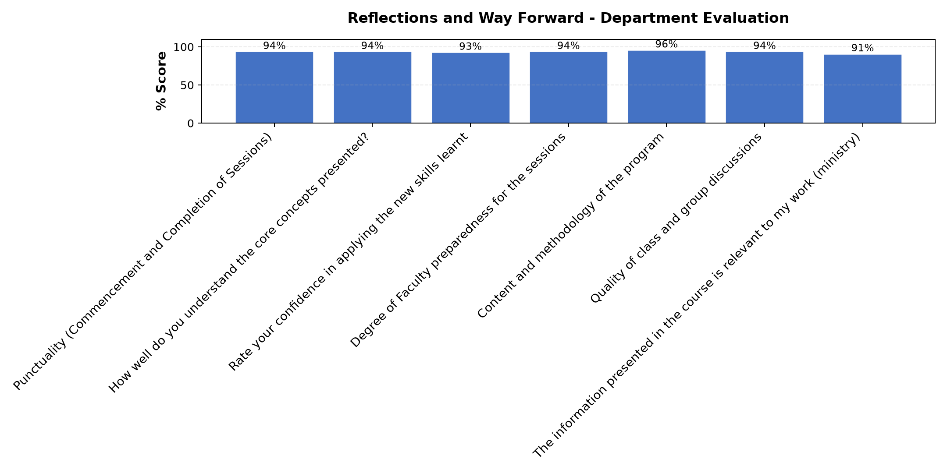

Comments & Feedback
No comments recorded.

What attracted you to the programme??

Comments & Feedback
- • Active participatory in this programme.
- • Coloured topic which represent our behavior in our apostolate and community life.
- • Tbe positive changes I saw the sisters who went through this course brought to their Social enterprises
- • Each and everything
- • How i see many sisters developing through the knowledge receivd on enterprise, and the activities they do example rearing chicken. Sunflower , schools. Etc.
- • All teachers were able to share with us the lesson
- • How can make surplus
- • Commitment of the presenters and the facillitator gently and patiently assist us
- • All
- • All that we discussed
- • Colours that is to be a good rguidance. Planning
- • How the reflection done

What topic would you recommend being expanded/improved in this programme’s units?

Comments & Feedback
- • All topics are good .
- • Business plan, fincial planning
- • Non
- • SB sustainability
- • Business modules
- • The evaluation of projects
- • Recruitment and retention of emoyees
- • Finance
- • Budgeting

Which teaching methods applied in the course did you enjoy/learn from the most?

Comments & Feedback
- • Interactive method
- • All topics
- • Planning and measuring social impact
- • Participation method
- • Marketing and SE SUSTAINABILITY
- • Interactive
- • Discussion and sharing skills
- • All topics The way of sharing experiences
- • Sharing and prensentation
- • Shairig

